01 · Technical Architecture
Project: StaffSync — Modern HR Management Solution (MERN) Document type: Story
Status: In Progress · Owner: Shiwani Jha

1. Overview
StaffSync is a role-based Human Resource Management (HRM) web application built on the MERN stack (MongoDB, Express.js, React.js, Node.js). It follows a classic three-tier architecture:
Tier | Technology | Responsibility
Presentation | React 18 + Vite + React Router | Role-aware dashboards and pages
Application | Node.js + Express 4 (REST API) | Authentication, authorization, business logic
Data | MongoDB (Atlas) + Mongoose 8 | Persistent storage of structured JSON documents
The system supports three main business roles — HR, Employee and Manager — plus an Admin role used for system-level administration. Each role sees a different set of dashboards, menu items and API permissions.

2. High-Level Architecture Diagram
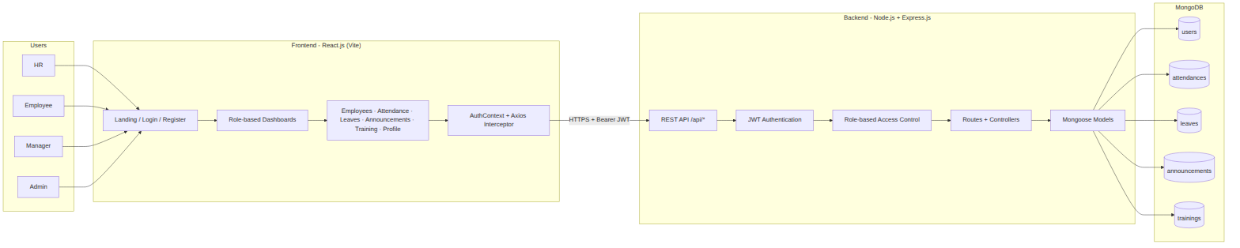

3. Frontend Architecture (React.js)

3.1 Folder structure
client/
├── index.html
├── vite.config.js
├── .env.example # VITE_API_URL
└── src/
├── main.jsx # App bootstrap (Router + AuthProvider)
├── App.jsx # Route table, Guard, Shell (sidebar/topbar)
├── api.js # Axios instance + JWT request interceptor
├── styles.css # Light-mode design system
├── context/
│ └── AuthContext.jsx # user, login, register, logout, updateUser
├── components/
│ └── UI.jsx # Shared UI building blocks
└── pages/
├── LandingPage.jsx
├── AuthPage.jsx # Login + Register (role selection)
├── Dashboard.jsx
├── Employees.jsx # "Employee Management" for HR
├── Attendance.jsx
├── Leaves.jsx
├── Announcements.jsx
├── Trainings.jsx
└── Profile.jsx

3.2 Role-based dashboards and features
Dashboard | Features
HR Dashboard | Manage employees (Add / Edit / Deactivate / View), approve or reject leave, view and administer attendance, post announcements, manage training
Employee Dashboard | Apply for leave, check in / check out, view attendance history, maintain personal profile, read announcements
Manager Dashboard | View employee directory, approve or reject leave requests, view team attendance, create and manage training and development programs
Admin Dashboard | Organization overview plus every HR capability; creates and promotes accounts

3.3 Frontend request flow
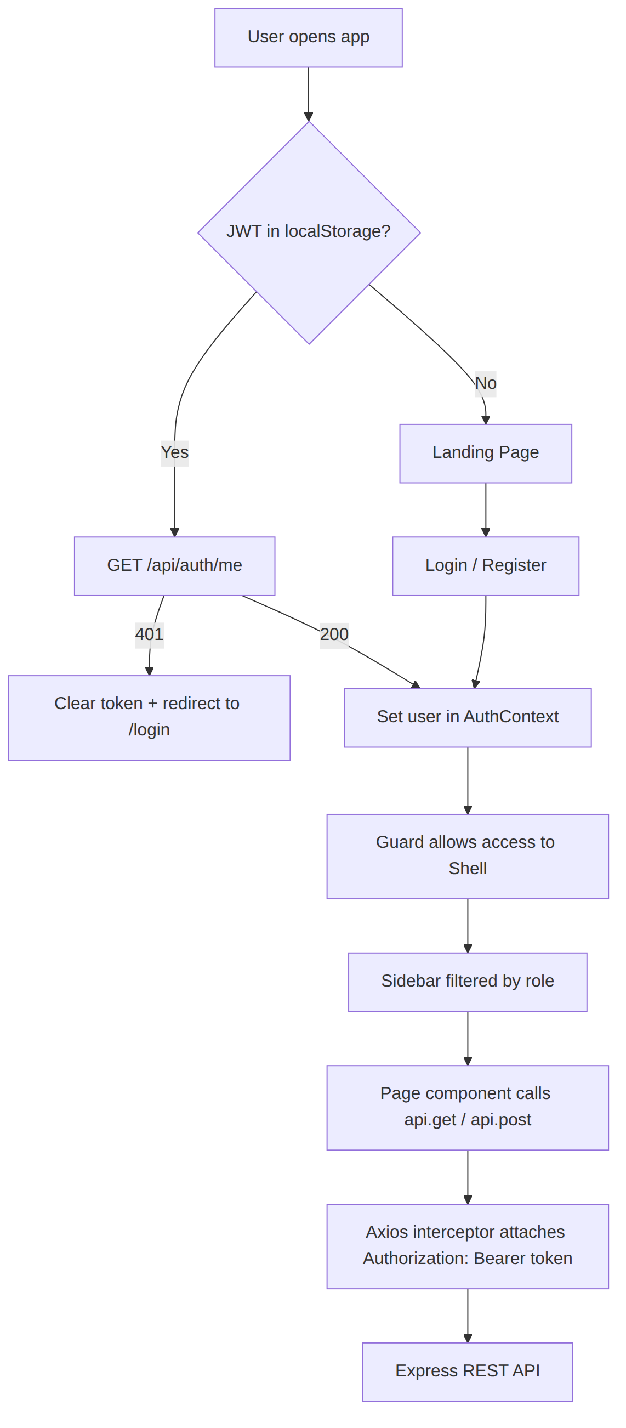
Key frontend mechanisms
- AuthContext stores the user, token and exposes login, register, logout, updateUser.
- Guard component blocks unauthenticated users and redirects to /login.
- Shell renders the sidebar; the Employees link is shown only to hr, manager, admin. HR sees it as Employee Management.
- api.js automatically injects Authorization: Bearer <token> into every request.

4. Backend Architecture (Node.js + Express.js)

4.1 Folder structure
server/
├── server.js # Express app, middleware, route mounting, DB boot
├── .env.example
├── scripts/
│ └── createAdmin.js # CLI to create/promote the first admin
└── src/
├── config/db.js # Mongo connection + legacy index cleanup
├── middleware/
│ └── authMiddleware.js # protect (JWT) + allowRoles (RBAC)
├── models/ # User, Attendance, Leave, Announcement, Training
├── routes/ # auth, employee, attendance, leave, announcement, training, dashboard
└── utils/asyncHandler.js # Async error wrapper

4.2 REST API surface
Module | Method & Path | Access
Health | GET /api/health | Public
Auth | POST /api/auth/register | Public (privileged roles need ROLE_SETUP_CODE)
Auth | POST /api/auth/login | Public
Auth | GET /api/auth/me | Any logged-in user
Auth | PATCH /api/auth/profile | Any logged-in user
Employees | GET /api/employees | admin, hr, manager
Employees | POST /api/employees | admin, hr
Employees | PATCH /api/employees/:id | admin, hr
Employees | DELETE /api/employees/:id (soft deactivate) | admin, hr
Attendance | GET /api/attendance (?all=true, ?date=) | All (own records; all for hr/manager)
Attendance | POST /api/attendance/check-in | All
Attendance | PATCH /api/attendance/check-out | All
Attendance | POST /api/attendance/manual | admin, hr
Leaves | GET /api/leaves (?all=true) | All (own; all for hr/manager)
Leaves | POST /api/leaves | All
Leaves | PATCH /api/leaves/:id/review | admin, hr, manager
Announcements | GET /api/announcements | All (filtered by audience)
Announcements | POST /api/announcements | admin, hr
Announcements | DELETE /api/announcements/:id | admin, hr
Training | GET /api/trainings | All
Training | POST /api/trainings | admin, hr, manager
Training | DELETE /api/trainings/:id | admin, hr, manager
Dashboard | GET /api/dashboard | All (stats vary by role)

4.3 Request lifecycle
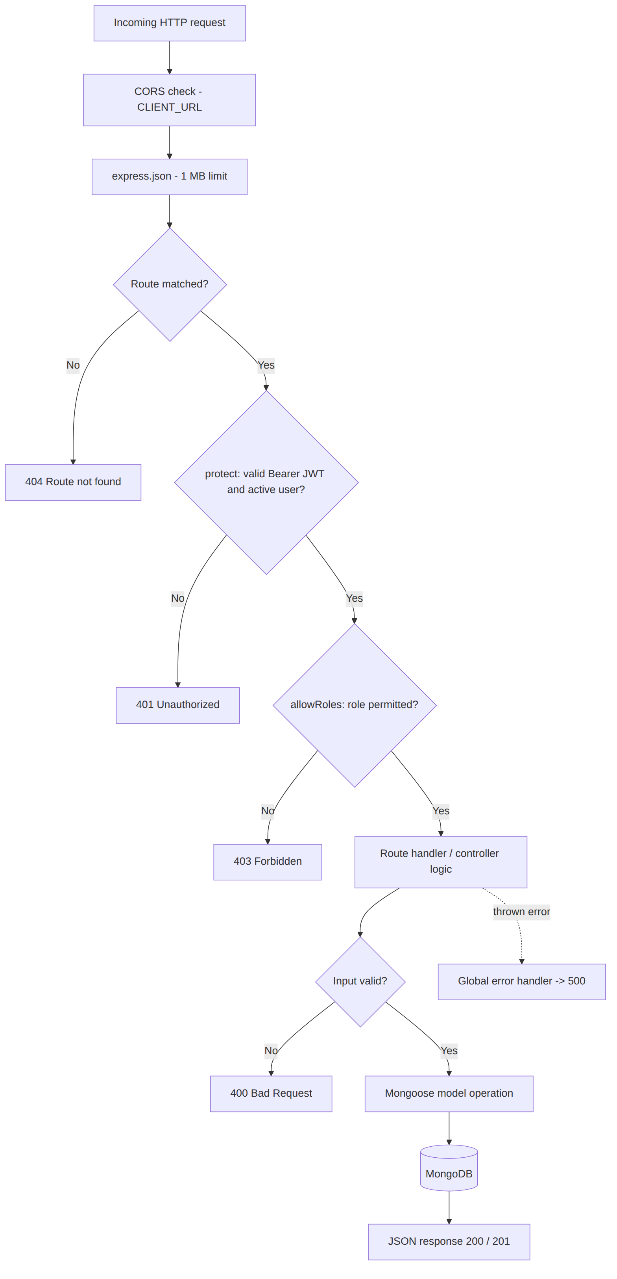

5. Authentication & Authorization

5.1 JWT login sequence
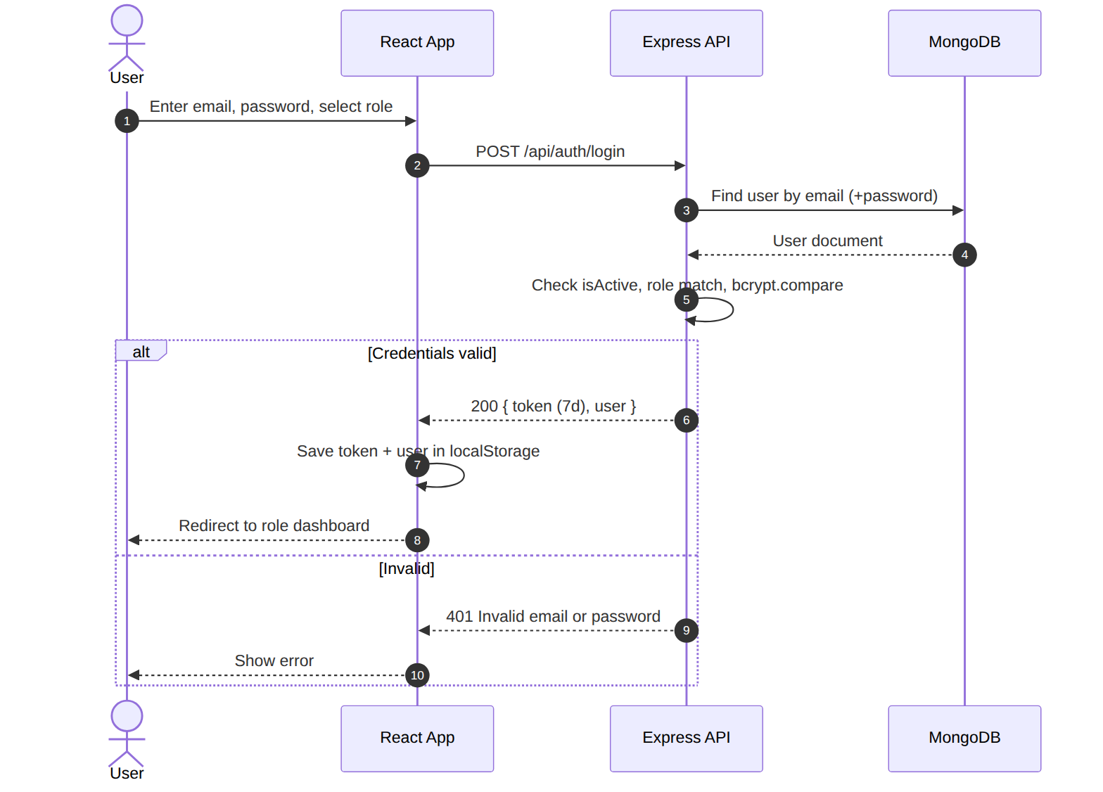

5.2 Security controls
Concern | Implementation
Password storage | bcryptjs with 12 salt rounds; password field is select: false
Session | Stateless JWT, expiresIn: 7d, signed with JWT_SECRET
Authorization | allowRoles(...) middleware on every sensitive route
Privileged signup | Manager/HR/Admin registration requires private ROLE_SETUP_CODE
Soft delete | Employees are deactivated (isActive:false), never hard-deleted; inactive users cannot log in
Transport | CORS restricted to CLIENT_URL; use HTTPS in production
Secrets | .env is git-ignored; only .env.example is committed

6. Database Architecture (MongoDB)
Collection | Purpose
users | Accounts and employee profiles (single source of truth)
attendances | Daily check-in / check-out records (unique per employee per date)
leaves | Leave requests and their review status
announcements | Organization-wide news targeted by audience
trainings | Training and development programs

7. Configuration
Variable | Location | Description
PORT | server/.env | API port (default 8000)
MONGO_URI | server/.env | MongoDB Atlas connection string
JWT_SECRET | server/.env | Long random signing secret
CLIENT_URL | server/.env | Allowed CORS origin (default http://localhost:5173)
ROLE_SETUP_CODE | server/.env | Invite code for privileged role registration
VITE_API_URL | client/.env | Base URL of the API

8. Deployment View
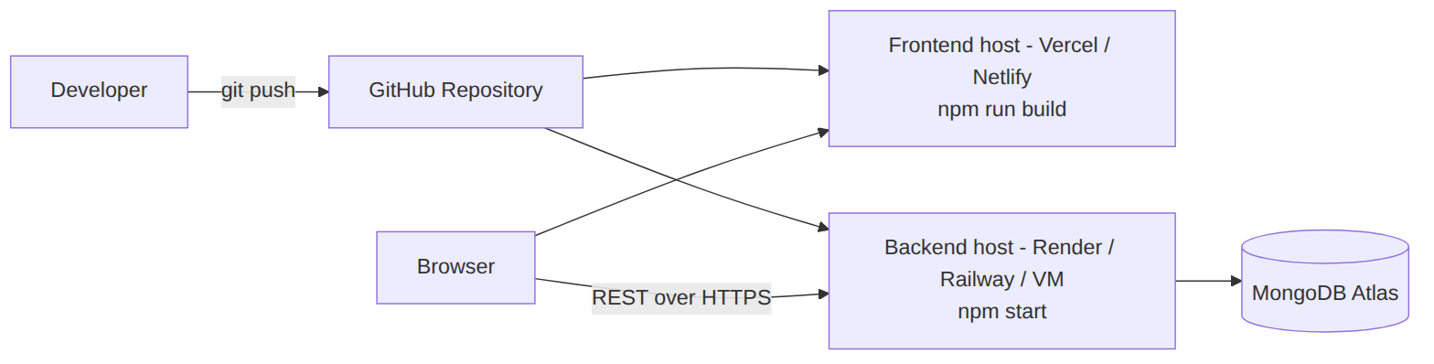

9. Planned Extensions (shown in the architecture diagram, not yet implemented)
Component | Notes
File Upload | Profile photos / documents via multer + cloud storage
Notification service | E-mail or in-app notifications for leave decisions and announcements
Reports | CSV/PDF export for attendance and payroll analysis

